
PT3/IPCQP/1221/A 24-JAN-2022
PERIODIC TEST – III (2021-22)
Subject: Informatics practices  Grade: XII |  | Max. Marks: 35  Time: 70 Minutes
SECTION A
 | Which of the following is a network topology :  - LAN  - Mesh  - Fibre Optics  - None of the above |  | 1
 | Name the protocol used for voice communication over Internet through compression of voice data into packets. |  | 1
 | An_______ is a software extension that adds extra features to a program |  | 1
 | The address of location of the document on the World Wide Web is called its___________. |  | 1
SECTION B
1. | Write the output  i) SELECT POWER(-3,2);  ii) SELECT MOD(-13,7); |  | 2
2. | Write the sql command to perform the following:  i) Display the date 10 years from now. Label the column "Future."  ii) Display the name of current month. |  | 2
3. | Differentiate between where clause and having clause with example. |  | 2
4. | What are cookies? Give any two applications of cookies in web design. |  | 2
5 | Write SQL query to create a table “Registration” with the following structure  Table: Registration  Field name Datatype Size Constraint  Reg_Id Integer 2 Primary Key  Name Varchar 20 Not Null  Course Varchar 10  Join_Dt Date |  | 2
6 | Consider the below mentioned table of Electronics,  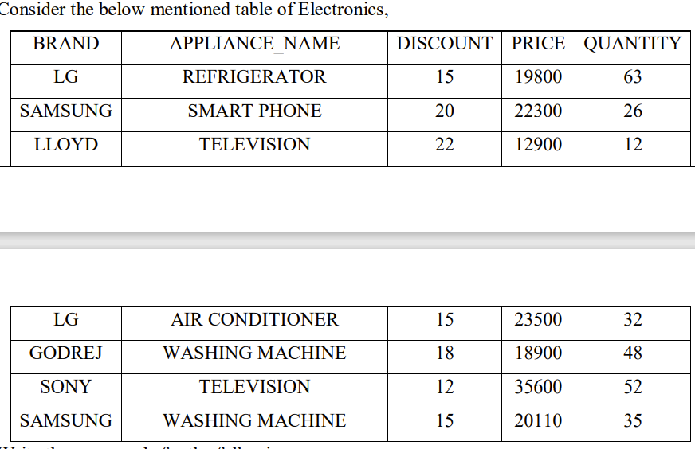  Write the commands for the following:  a. Display the total price of each brand.  b. Count the total number of televisions available in the table.  c. Display the Brand and Name of Appliance with maximum discount |  | 3
7 | (a) While creating the table Student last week, Ms. Sharma forgot to include the column Game_Played. Now write a command to insert the Game_Played column with VARCHAR data type and 30 size into the Student table? (1)  (b) Ms Sharma forgot to add a primary key while creating the student table. Write the query to set Admno as the primary key.(1)  (c) Write the command to display the structure of student table.(1) |  | 3
8 |  |  | 3
 | Section C
1. | Write the SQL commands for qns(i) to (7) & output for 8 to 10 based on the following table: Patient  1.Display the unique wards in the patient table.  2. Display the name of patients that is not starting with K.  3. Display number of patients in each ward  4. Display the details of Female patients admitted in October month. |  | 4
  PNAME | AGE | WARD | ADMITDATE | TARIFF | GEN
  KARIM | 32 | ORTHO | 2012-02-19 | 1600.0 | M
  ARUN | 12 | SURGERY | 2012-11-01 | 1900.0 | M
  ZAFAR | 30 | ENT | 2012-01-12 | 1500.0 | M
  KIRAN | 16 | ENT | 2012-02-24 | 1500.0 | F
  ANKUR | 29 | CARDIO | 2012-02-20 | 1800.0 | F
  SUHAIL | 45 | ORTHO | 2012-02-22 | 1600.0 | F
  KETAN | 19 | CARDIO | 2012-01-13 | 1800.0 | M
  ANUSHA | 23 | SURGERY | 2012-02-21 | 1900.0 | F
  ARPRIT | 42 | CARDIO | 2012-02-23 | 1800.0 | M
  TARUN | 53 | SURGERY | 2012-01-17 | 1900.0 | M
  GAURAV | 39 | ENT | 2012-10-11 | 1500.0 | F
2 | Consider a table SALESMAN with the following data:  Write SQL queries using SQL functions to perform the following operations:  a) Display salesman name and bonus after rounding off to zero decimal places.  b) Display the position of occurrence of the string “ta” in salesman names.  c) Display the four characters from salesman name starting from second character.  d) Display the month name for the date of join of salesman  e) Display the name of the weekday for the date of join of salesman |  | 5
  SNO | SNAME | SALARY | BONUS | DATEOFJOIN
  A01 | Beena Mehta | 30000 | 45.23 | 29-10-2019
  A02 | K.L.Sahay | 50000 | 25.34 | 13-03-2018
  B03 | Nisha Thakkar | 30000 | 35 | 18-03-2017
  B04 | Leela Yadav | 80000 | NULL | 31-12-2018
  C05 | Gautam Gola | 20000 | NULL | 23-01-1989
  D07 | Neena Sharma | 50000 | 27.89 | 18-03-1999
3 | Uttaranchal College of Advanced Studies has 5 departments where it runs its operations (shown below):  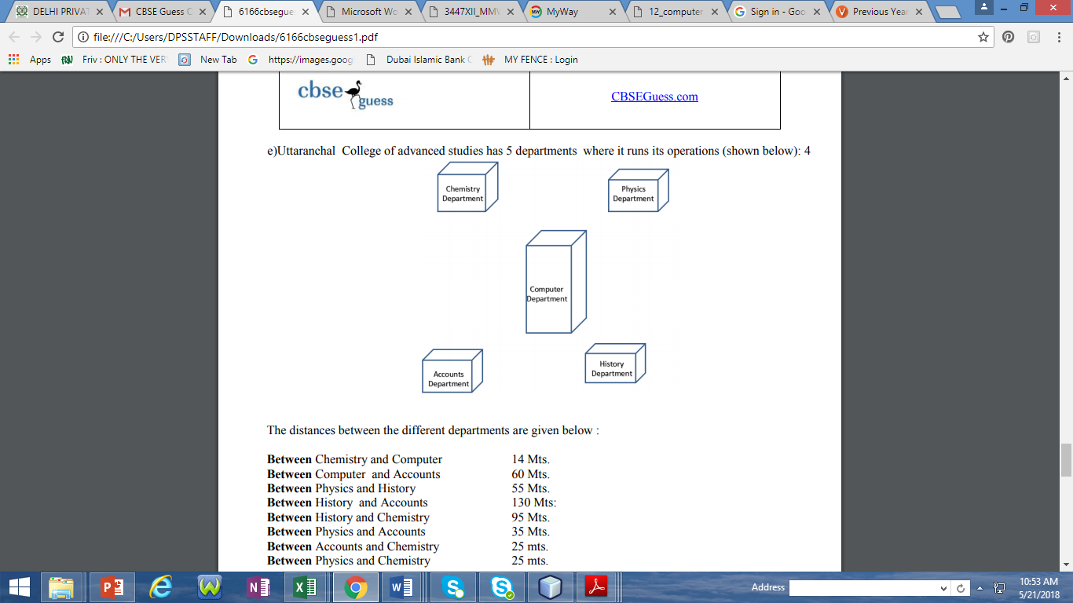  The distances between the different departments are given below :  Each wing contains following number of computers : |  | 4
  Between Chemistry and Computer | 14 Mts.
  Between Computer and Accounts | 60 Mts.
  Between Physics and History | 55 Mts.
  Between History and Accounts | 130 Mts:
  Between History and Chemistry | 95 Mts.
  Between Physics and Accounts | 35 Mts.
  Between Accounts and Chemistry | 25 mts.
  Between Physics and Chemistry | 25 mts.
  Departments | No. of Computers
  Physics | 10
  History | 70
  Chemistry | 305
  Accounts | 103
  Computer | 3
i | Suggest suitable cable layout(s) for connecting the wings .Also mention the topology
ii | Where do you think the server should be placed and explain why? Give reason.
iii | Suggest the transmission medium should be used if the organization wants the most efficient option to connect Delhi Head Office. Also mention the type of network.
iv | Where and why should repeaters and hub be used?
***

